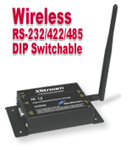

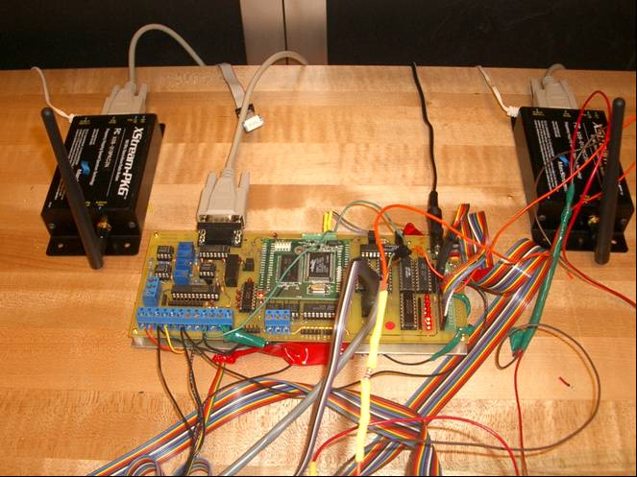
The Radio Frequency Modem used was a Maxstream 19.2k BPS modem. It works best when both modems are in line of sight, such as one connected to a laptop and the other onboard the crew shell.

This RF Modem is connected to a serial port on the ES308 Board (Serial Port B). It can send not only raw voltage readings from the sensors but also any extrapolated data from those sensor readings that the Rabbit computed. It can also receive data from the other modem and display it on the LCD Display for the coxswain to read.
This RF modem will be connected to a land based computer or a laptop that is inside a powerboat used by a coach. It will allow the information from the Virtual Coxswain to be passed to it and viewed. This will allow not only the LCD Display to show the results from the sensors but also anyone with a laptop and RF modem to view as well.

Enclosure 13

